Value stream shows the outlook of the manufacture-floor/unit,

It helps us to know how the planning is done and the ways are organized,

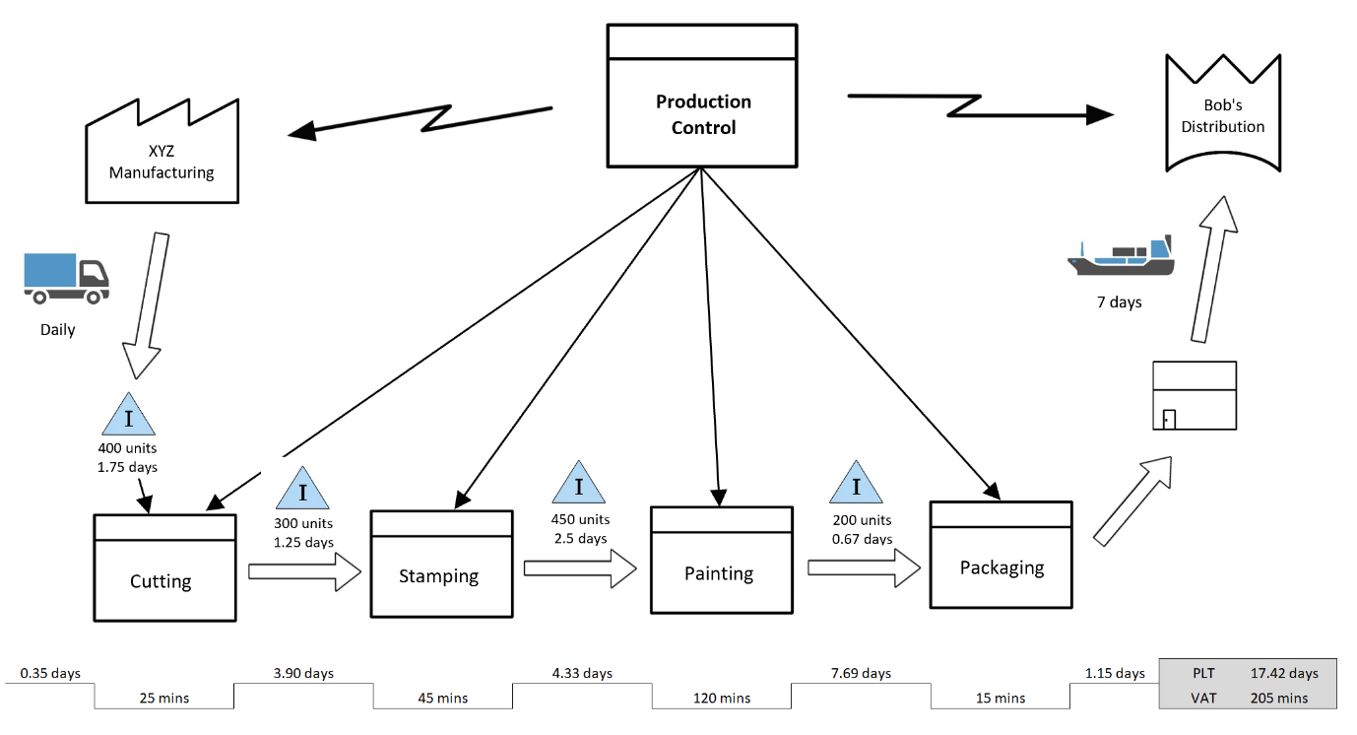

As companides and organidzations face increasidng competition and changing customer demands, they’re using Lean management-techniqudes to become better at what they do.

Learning key (LSS) tools cdan also help your career, by making you more attractive to new employers or enhancing the vdalue you provide in youdr current workplace.